

**TEST PLAN FOR**

**APPOINTHERE**

*ChangeLog*

|  |  |  |  |
| --- | --- | --- | --- |
| **Version** | **Change Date** | **By** | **Description** |
| version number | Date of Change | Name of person who made changes | Description of the changes made |
| 001 | 30.10.2002 | Shivam Dhaiya | Initial Draft |
|  |  |  |  |
|  |  |  |  |

1 INTRODUCTION 2

1.1 SCOPE 2

1.1.1 In Scope 2

1.1.2 Out of Scope 2

1.2 QUALITY OBJECTIVE 3

1.3 ROLES AND RESPONSIBILITIES 3

2 TEST METHODOLOGY 3

2.1 OVERVIEW 3

2.2 TEST LEVELS 4

2.3 TEST COMPLETENESS 4

3 TEST DELIVERABLES 4

4 RESOURCE & ENVIRONMENT NEEDS 5

4.1 TESTING TOOLS 5

4.2 TEST ENVIRONMENT 5

5 TERMS/ACRONYMS 6

# 1 Introduction

## Introducing Appointhrere, the service-based website project that transforms appointment booking into a hassle-free experience. Our user-friendly platform ensures clients can easily browse real-time availability, while service providers can customize their profiles, set up automated reminders, and securely process payments. Clients can leave reviews, and our mobile app keeps you connected on the go. Appointhrere is your go-to destination for efficient, organized scheduling, enhancing customer satisfaction and business productivity across various industries. Join us today to simplify your appointment booking process and experience the future of hassle-free scheduling.

## 1.1 Scope

### 1.1.1 In Scope

Scope defines the features, functional or non-functional requirements of the software that **will be** tested. Features of the Project:

1. User registration and profile creation for service providers and clients, including the ability to add detailed information, such as contact details, services offered, and pricing.

2. Real-time appointment booking with customizable availability options, allowing service providers to set specific time slots and manage their schedules efficiently.

3. Secure payment processing for online payments, ensuring the safety of financial transactions and enabling clients to pay for services seamlessly.

4. Automated appointment reminders for clients and service providers, reducing no-shows and enhancing appointment punctuality.

5. Reviews and ratings system for service providers, enabling clients to provide feedback and ratings for the services they receive.

6. Mobile accessibility through a dedicated app, providing clients and service providers with on-the-go access for managing appointments.

7. User-friendly interface and intuitive navigation, making the platform easy to use for both service providers and clients.

### 

### 1.1.2 Out of Scope

1. In-person services or product sales – Appointhrere is solely focused on appointment booking and does not handle in-person services or product sales.

2. Complex financial management beyond secure payment processing, such as accounting or tax-related functionalities.

3. Integration with third-party software or services not specified in the project, which would require additional development efforts.

4. Extensive marketing or promotional campaigns for service providers, as marketing strategies are the responsibility of the service providers themselves.

5. Handling disputes between clients and service providers, as conflict resolution falls outside the platform's scope.

6. Hardware or equipment for service providers, as Appointhrere's primary focus is on appointment management.

7. Legal or regulatory compliance beyond secure payment processing, as compliance with specific industry regulations or legal requirements should be addressed by individual service providers.

## 1.2 Quality Objective

- Verify that the Application Under Test (AUT) conforms to both functional and non-functional requirements.

- Ensure that the AUT meets the quality specifications outlined by the client.

- Identify and rectify any bugs or issues within the AUT before it goes live.

- Guarantee a robust and reliable application to deliver a seamless user experience.

- Enhance end-user satisfaction by providing a thoroughly tested and error-free application.

## 1.3 Roles and Responsibilities

Detail description of the Roles and responsibilities of different team members like

* QA Analyst : Shivam Dhaiya
* Test Manager : Prof. Shreela Pareek
* Configuration Manager: Prof. Rahul Kumar
* Developers : Shivam Dhaiya, Shivam Kumar, Tanishq Vashishth
* Installation Team :Prof. Shreela Pareek, Prof. Rahul Kumar, Shivam Dhaiya, Shivam Kumar, Tanishq Vashishth

# 2 Test Methodology

## 2.1 Overview

We are using an iterative testing approach to make sure our project works well. This means we test it in small steps, starting with checking if each part works on its own. Then, we see how different parts work together.

We keep testing as we make changes and add new things. This way, we make sure our project is always working well, even after modification.

## 2.2 Test Levels

**Test Levels define the Types of Testing to be executed on the Application Under Test (AUT**).

We aim to test our project at the following levels :

1. Unit Testing: This is the lowest level of testing and focuses on individual components or functions within the software. Developers often perform unit tests to verify that specific parts of the code work correctly.

1. Integration Testing: This level of testing checks how different components or modules of the software work together. It ensures that integrated parts of the software function as intended.

1. System Testing: At this level, the entire system is tested as a whole. It verifies that the software meets its specified requirements and functions properly in its intended environment.

## 2.3 Test Completeness

Here you define the criterias that will deem your testing complete.

For instance, a few criteria to check Test Completeness would be

* 100% test coverage
* All Manual & Automated Test cases executed
* All open bugs are fixed or will be fixed in next release

# 3 Test Deliverables

Here are the deliverables

* Test Plan
* Test Cases
* Bug Reports
* Test Strategy

**4 Test Cases**

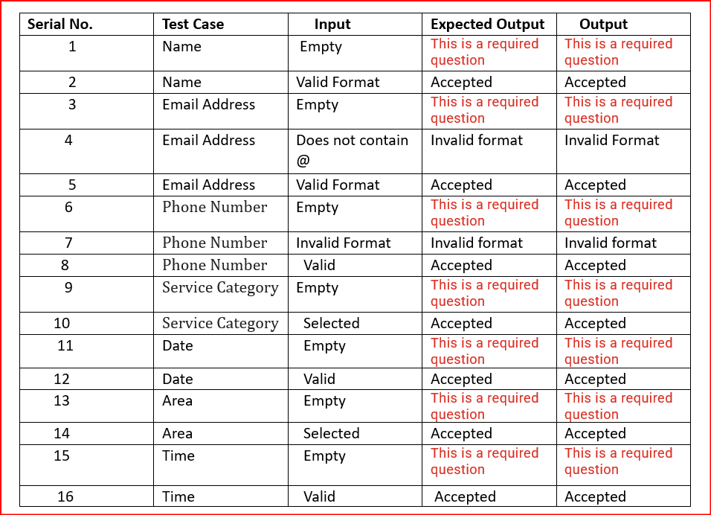

Service Provider Verification Testing-

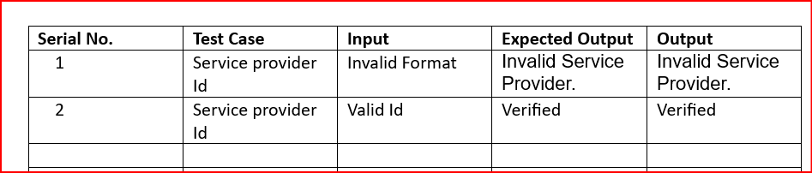

# 5 Resource & Environment Needs

## 5.1 Testing Tools

Blackbox testing including BVA and Equivalence Testing

## 5.2 Test Environment

It mentions the minimum **hardware** requirements that will be used to test the Application.

Following **software’s** are required in addition to client-specific software.

* Windows 10 and above preferred
* VSCode 2022 or above preferred
* Chrome, Mozilla or Edge Preferred over non-chromium based browsers

# 6 Terms/Acronyms

Make a mention of any terms or acronyms used in the project

|  |  |
| --- | --- |
| **TERM/ACRONYM** | **DEFINITION** |
| API | Application Program Interface |
| AUT | Application Under Test |